Water Quality Monitoring in the Sackville River Watershed 2015 and 2016

Bill Ernst and Damon Conrad

Sackville Rivers Association
November 2016.

Introduction
The Sackville River watershed encompasses approximately 151 km² (Sterling et al. 2014) composed of approximately 14 (WWF 2016) or 15 (Brunner 2010) sub-basins, the largest of which is the Little Sackville River. The watershed contains 15 lakes, ponds, wetlands, rivers and brooks. The river is the primary freshwater source of the Bedford Basin.
The river originates in the Meguma geological formation of either the Halifax Group or the Goldenville group which are primarily metasandstones, metasiltstones or slates. There is also some pyrite and pyrotite, in those formations which may generate acid drainage when exposed (Horne et al. 2009). It flows through granite and glacial till (Brunner 2010) as well as drumlins of clayey silt throughout much of its length (Nova Scotia Natural Resources 2016). The watershed soils are almost entirely from glacial drift and predominantly course textured material derived from quartzite; however there are some moderately coarse soils derived from granite and moderately fine textured soils derived from mudstone, shales and sandstones (MacDougall et al. 1963). The main stem of the river has a mostly moderate gradient and contains riffles as well as stillwater sections.
The watershed contains large areas of urban development consisting of residential, commercial and industrial activity in the lower stretches, where it passes through Lower Sackville, a town of approximately 40,000 people (Brunner 2010). It receives storm water discharge in that area, but no municipal wastewater. The upper stretches contain less dense residential properties in a ribbon development which roughly parallels the river and whose domestic waste treatment is primarily by septic fields. It also drains large areas of mixed forest which has been subjected to various levels of harvesting activities over the past several centuries. The middle stretches of the river contain a closed landfill that once served the municipality of Halifax and which has a liquid, wetland treated discharge. An operating sawmill is directly adjacent to the lower stretch of the main river as well as a sawmill on the Little Sackville River. There is a golf course within the watershed.
Surface water quality can be affected by a number of factors, including the geology it flows through, characteristics of precipitation it receives, the surrounding plant communities, as well as the human activities within the watershed. Industrial and domestic discharges can have a substantial effect on water quality. Domestic sewage components including nutrients and bacteria can reach watercourses via discharges from wastewater treatment plants, septic fields as well as those which are untreated. Because urban development includes many impervious surfaces such as roads, parking lots, sidewalks and rooftops, precipitation events cause larger volumes of water to flow into the receiving environment through storm water collection systems than would normally occur if water was allowed to percolate or run through naturally vegetated soils. This increased water flow can greatly affect the hydrology, causing re-suspension of previously deposited sediments, which may contain bacteria and contaminants. The water collected by storm water systems in an urban environment contain various chemicals such as: hydrocarbon residues and their combustion products (polycyclic aromatic hydrocarbons – PAHs); heavy metals including nickel, cadmium, copper, zinc, and lead (USEPA 2003).
Runoff from domestic lawns, developed parkland and golf courses contain measureable quantities of nutrients such as nitrates and phosphorus as well as pesticides which can greatly affect the biological communities in the aquatic receiving environment.
Soils exposed as a result of construction activities increase the amount of sediment entering water bodies, which can affect oxygen and light availability as well as reducing the quality of habitat on the stream bottom.
Many impervious surfaces in an urban environment absorb heat and produce discharges of abnormal temperature during precipitation events which can have drastic effects on the biological communities within the receiving environment, particularly during the first flush which can produce a thermal shock. The capacity of the water to carry oxygen is greatly reduced by elevated temperatures. Changes in riparian vegetation, as well as alterations in hydrology such as riffle to pool ratios can result in elevated water temperatures. Changes in climatic conditions due to release of greenhouse gases also has the potential to alter thermal conditions in the watercourse over the long term.
To improve safety during the winter months, road, parking lot and sidewalk surfaces are treated with salts and other de-icing compounds, which runoff through collection systems or directly to watercourses. Such discharges have been shown to have effects on the biological communities within those watercourses (Wallace and Biastoch 2016).
Due to the possibility of environmental degradation from all of the above influences, it is important to monitor the conditions within the river system as a measure of its health. Monitoring water quality can have a number of objectives. Identifying changes with time, under various environmental conditions such as dry or wet and with seasonality, involves measurement of the same parameters at the same locations over some period of time. Monitoring to identify the locations of pollution entry to the watercourse involves multiple sampling locations and timing with environmental conditions, such as rain events which may maximize the possibility of measuring changes in parameter values. Monitoring for the purpose of assessing ecosystem health usually involves comparison of parameter measurements with standards or known biological effects levels.
The Sackville Rivers Association has been involved in monitoring in the Sackville River for at least a decade. The objectives, intensity, parameters, timing and measurement techniques have varied substantially during that time, making trend analysis difficult. The most recent and reliable data were collected in 2015/2016 and this report attempts to consolidate and analyze that data.
Monitoring Methods.
Water quality measurements were taken on a calendar, rather than an environmental event basis. Sampling intensity was greatest during the summer months when field assistance was available in the form of summer students, however sampling was also conducted in fall and winter on a more limited and periodic basis. The monitoring parameters were: water temperature; air temperature; dissolved oxygen; specific conductivity; total dissolved solids; salinity and pH; measured by a Wet Pro YSI multi-probe meter. Full calibrations were done prior to sampling on a biweekly basis by comparison with known standards with calibration of the DO sensor taking place prior to each sample period.
Water temperature controls many processes in aquatic systems and defines the biological communities which exist in those systems. Temperature controls the basic biological activities within water systems including nutrient processing and energy flow. Rapid temperature fluctuations are known to have negative effects. Some organisms have a wide tolerance range, but others do not. Fish have specific temperature requirements for survival; for example adult Brook trout (Salvelinus fontinalis) are generally found in water with temperatures below 20ºC, but their eggs will not survive in temperatures above 11.7ºC (Scott and Crossman 1973). It should be noted, however that temperature distributions within watercourses are not even and breeding patterns (Brook trout are fall breeders) may mean that seasonally high temperatures can be avoided. Because successful Atlantic salmon reproduction within the Sackville River system is an objective of the Sackville Rivers Association a threshold of concern was established at 22.8ºC, which is the temperature above which salmon generally do not enter rivers to spawn (NOAA 2016).
The dissolved oxygen is an important parameter, since it is essential to all aquatic animals which have an aerobic metabolism, but also since it can affect the solubility of many organic nutrients (Wetzel 1975). Dissolved oxygen is measured as an absolute amount (mg/L), but since the solubility of oxygen in water varies according to temperature, it is also expressed as a function of the saturation possible in water at that temperature (%). Various organisms have different requirements for oxygen. The Canadian water Quality Guideline for the Protection of aquatic Life (CCME 1999) has been set at 9.5 mg/L for early aquatic life stages and 6.5 mg/L for other life stages in cold water. It is important to note, however that such guidelines are set for chronic or long term exposure and are not applicable to short term conditions. Since Atlantic salmon (Salmo salar) are a ‘touchstone’ species for the Sackville Rivers Association, and since the National Oceanic and Atmospheric Administration (NOAA 2016) has determined that Atlantic salmon generally migrate into freshwaters which have oxygen concentrations of 5mg/L or greater, that level is judged to be a more appropriate threshold for concern in this case.
Specific conductance is a measure of the concentration of ionized salts in that water (Wetzel 1975) and is generally characteristic of the soils and bedrock that the water flows through, however sea spray can also affect watercourse salinity across the Nova Scotia landscape. Increased specific conductance in a watercourse may indicate entry of pollutants (Nova Scotia Salmon Association 2014) however it does not identify the kind of pollution. Specific conductance changes might be associated with sewage, soil removal from certain kinds of bedrock, storm water from areas where pollutants such as metals or road salts may have collected, or industrial discharge. There is a correlation between conductance and pH in the intermediate pH of bicarbonate fresh waters, but not in waters of low salinity or high dissolved organic matter (Wetzel 1975). Specific conductance does not have a water quality guideline and is primarily used to identify locations requiring additional investigation. The Nova Scotia Salmon Association (2014) sets a range of 100- 500 µmhos/cm as an indicator of water quality supporting good fisheries
Salinity values reported by the YSI unit is a calculation from temperature and conductivity readings, based on total ion concentrations and cannot be assumed to be simply a measure chloride from seawater or road salt intrusions (Nova Scotia Salmon Association 2014). It should be noted however that road salt entering fresh water systems is known to have deleterious effects on aquatic biota and a long term aquatic guideline of 120mg/L as well as an aquatic invertebrate threshold of 80 mg/L have been established (Wallace and Biastoch 2016). It is also recognized that chloride concentrations in watercourses draining areas where road salting is taking place continue rise (Wallace and Biastoch 2016).
The pH measurement represents how acidic or basic water is with readings below 7 being increasingly (on a logarithmic scale) acid and readings above 7 being increasingly basic. Increased acidity of water in eastern Canada has been negatively impacting normal aquatic functions for some time. Acidity increases in Nova Scotia watercourses have been shown to be the result of acid in precipitation due to the combustion of fossil fuels (Atlantic Salmon Federation 2016) as well as from exposure of acid generating rock (White et al. 2014). Aquatic organisms have a tolerance for a range of pH and there is no ‘safe’ pH level for all organisms. Acceptable pH to aquatic organisms depends on many factors including: prior pH acclimation, temperature, oxygen concentration and presence of various ions (McKee and Wolf 1963). The productivity of natural water bodies can be negatively affected outside a range of 6.5- 8.5 (NAS 1972) and most freshwater fish survival is threatened outside a pH range of 5.0-9.0 (Alabaster and Lloyd 1980). The sensitivity of Atlantic salmon to reduced pH varies according to life stage, with parr and smolts tolerating approximately 4.6 but fry tolerating only 5.0 (Farmer 2000). The Atlantic Salmon Federation has established a survival threshold pH of 5.4 for long term survival (Atlantic Salmon Federation 2016) and for the purposes of interpreting this data set; therefore, a threshold of 5.4 was accepted.
Sampling Sites
Sample locations (Figure 1) were selected based on a distribution throughout the watershed, proximity to known pollution sources, as well as ease of access.

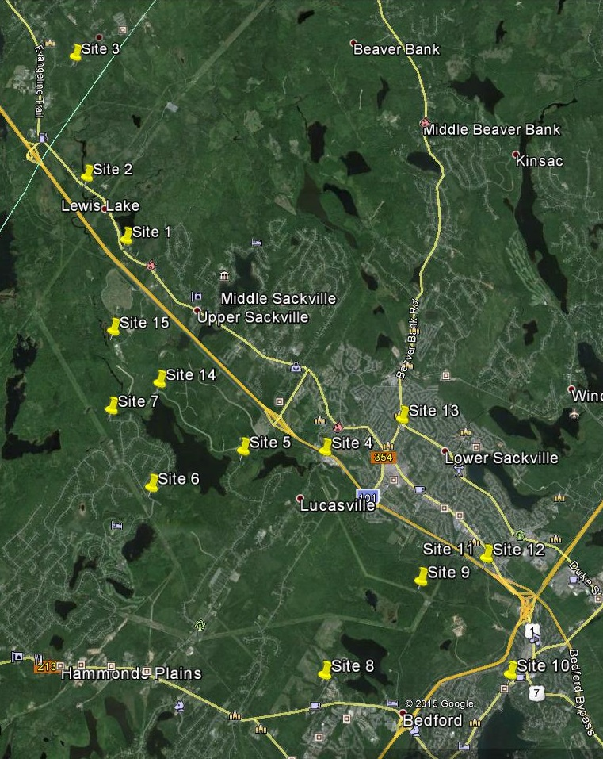
Figure 1. Water quality monitoring stations within the Sackville River watershed, 2015-2016.

Site 1 – Lewis Lake Outfall/Crossing of Highway 1 Upper Sackville
Site 1 water samples are from a discharge from a large catchment area previously found to have low pH and collecting from a largely undeveloped mixed forest area with scattered historical industrial uses such as abandoned mines and pits which exposed bedrock during their operation. Although Lewis Lake itself contains some residential development around a portion of the lake, it is relatively low density that is more rural than urban, with much of the development occurring along Highway 1. Those residences are on domestic septic sewage treatment systems. Samples from this site collects outflow from the lake and captures some runoff from Highway 1. The site is downstream of Sites 2 and 3.
Water temperature at this site was well within the range for salmon and trout (mean 12.1ºC ± 7.8ºC S.D) with only one exceedance of the temperature threshold (5%) occurring in August. Dissolved oxygen, however, was lower than for most sites, having a mean and standard deviation of 8.3mg/L ± 3.9mg/L S.D. and being below the 5mg/L threshold 27% of the time (in June and July). Conductivity had a mean of 111.0 ± 64.5 µmhos/cm., indicating relatively low ion content. It was higher in the early part of the summer, but below the NSSA guideline of 100 µmhos/cm. for 54% of the readings by late summer and fall (Fig. 2). The pH at this site was also relatively low, (mean 5.4± 0.7) and below the 5.4 threshold 50% of the time. The low readings were primarily in the winter months and lowest was pH 3.7 in mid-January. The extremely low pH for this site is obviously cause for concern since it would prohibit salmon survival at that location. Specific conductance and pH seem to be roughly correlated at this site.

SPC µmhos/cm
SPC µmhos/cm
SPC µmhos/cm
Figure 2. Specific conductivity and pH at Site 1.
White (2004) reported that the mean summer month temperatures at this site in 2001 – 2003 was generally in the optimal range for salmonids, ranging from 17.0-19.9 ºC, the best in the main stem of the Sackville River. The mean oxygen concentration at that time was fairly low, ranging from 6.3-6.9 mg/L. He reported the mean summer pH ranged from 5.6 -6.1, which was considerably better than that reported by Watt et al. (1996) for the period 1981 to 1995 when annual means ranged from 4.73 to 4.92. In mid-July 1978 sampling, Beanlands (1980) reported an unstratified water temperature of 23.0-23.5 ºC, a dissolved oxygen concentration of 6.0mg/L and a pH of 6.0 in Lewis Lake. These data are very comparable to those reported here and indicate no deterioration, and possibly somewhat improved water quality with time.
Site 2 – Sackville River at Highway 1 crossing Upper Sackville
Site 2 is located on the main Sackville River where it crosses Highway 1 and is situated to sample the runoff from a mixed forest area where mining/quarrying activities have occurred in the past. A new quarry was begun in the upper part of the watershed in the fall of 2015. The upper reaches of the river also contain bog area wetlands. There is also some low density rural development which has septic field sewage treatment and a power line cut near this sampling site. This site is downstream of Site 3.
Water temperature at this site was generally in an optimal range for resident salmonids (mean 12.8ºC±9.1ºC), however it did exceed the suitability threshold in the summer months, 14% of the time. Dissolved oxygen was also generally optimal for resident salmonids (mean 9.7mg/L ± 3.4mg/L), however it was lower in the summer and was below the acceptability criterion on only one occasion.
Specific conductance was very low (mean 56.9µmhos/cm. ± 15.8µmhos/cm.) and always below the 100µmhos/cm. threshold of good stream health.
The pH at this site was in the lower range (mean 5.7 ± 1.0) and was below the acceptability threshold on 6 occasions (27% of measurements), primarily in the winter months. The very low pH at this site indicates it is not suitable for salmon survival.
This site is somewhat higher on the river than where Watt et al. 1996 recorded very similar (mean) pH values in the years 1981 to 1994. Major pH alteration in the watercourse between the SRA and Watt et al. sites probably would not have occurred since both are above the landfill site.
Specific conductance and pH seem to be roughly correlated early in the sample period but less so during the winter sampling.

SPC µmhos/cm
Figure 3. Specific conductance and pH at site 2.

Site 3 – South Uniacke Road Bridge South Uniacke
Site 3 is the upper-most site in the watershed and represents the nearest-to-river-origin water quality. The watershed in this area is largely undeveloped and composed primarily of lowland mixed forest with extensive areas of bog wetlands. The river is slow and meandering with some low density rural residential development along the few roads in this area. It also collects from areas which had previously been mined for gold as well as pits which had been excavated for fill. A new quarry was begun in the fall of 2015, approximately 4km above this sampling site.
Water temperature at this site is generally optimal for resident salmonids (mean 12.5±8.1ºC) and was never above the acceptability threshold. Dissolved oxygen was also near optimal most of the time (mean 9.8 ± 3.2 mg/L), however it was lower during the summer months and below the acceptability criterion on one occasion in June.
The specific conductance was also very low and relatively constant (mean 53.4 ± 7.9 µmhos/cm.) and always below the 100 µmhos/cm. lower limit of acceptability (Figure 4), indicating a lower productivity area.
The pH at this site was again generally very low (mean 5.4 ± 0.8) and lowest in the winter months (Figure 4). It was below the acceptability criterion approximately 52% of the sampling occasions, indicating it’s unsuitability for salmon reproduction. Again, there appears to be a rough correlation between specific conductivity and pH.
SPC µmhos/cm
SPC µmhos/cm
SPC µmhos/cm
SPC µmhos/cm
Figure 4. Specific conductance and pH at site 3.
The occurrence of low pH during winter has a number of possible explanations. It is known that photosynthetic processes can increase the pH of natural waters, to the extent that daily fluctuations can be up to 2 pH units (Boyd 1990). In the winter months when waters are cold and light is limited, such pH moderation would be minimal. Bog systems, particularly those dominated by Sphagnum sp., are known to reduce the pH of water which originates from them (Wetzel 1975), and the upper reaches of the river have extensive surrounding bog wetlands. Furthermore, it has also been determined that during winter, the weight of snow cover can increase the water discharge from bogs where that water has had a substantial residence time and therefore may have increased acidity (Parent 2016). The upper reaches of the Sackville River also drain the Goldenville formation, which is known to produce acidic runoff when overburden is removed (White et al. 2014). Past and present mining and excavating activities could still be allowing acid to be produced from exposed rock. Finally, acid precipitation is still occurring in this region and the upper watershed has been previously shown to have poor buffering capacity (Gorham 1957) and the conductivity measurements from the SRA monitoring would support that evidence. Such lack of buffering capacity would make the acid precipitation effects even more pronounced. In fact the pH measurements in these locations were not substantially different than those of Gorham in the 1950s, who measured a winter pH of 4.96 on Lewis Lake.
White (2004) reported mean water temperatures at this site were 5.8ºC during summer months of 2003 and mean oxygen concentrations were 6.9 mg/L. She reported that mean pH at that time was 5.8, comparable to the values recorded in 2015.
Site 4 – Outflow from Webber Lake Lucasville
Site 4 was at the outflow of Webber Lake, which has very low residential density which have onsite septic systems, and is surrounded by a mixed softwood/hardwood forest. Site 4 represents the approximate middle of the watershed. This site collects flows from Sites 1, 2, 3, 5, 6, and 7.
Water temperature is more elevated at this site (mean 14.3 ± 8.4ºC). Exceedances of the upper acceptable threshold occurred in July and August and were 18% of observations. Warming of water is obviously occurring as it passes through McCabe Lake and Webber Lake. Dissolved oxygen was relatively optimal for resident salmonids at this site (mean 9.8 ± 3.1 ºC) and only below the acceptable criterion on one occasion (June).
Specific conductance was still quite low at this site (mean 62.0 ± 9.6 µmhos/cm.) and never above the lower productivity threshold. The low values are probably indicative of relatively low pollutant inputs.
The pH at this site was acceptable for resident salmonids with little variance (mean 6.12 ± 0.5) and there were no exceedances of the acceptability threshold. This site is below the landfill discharge, which probably has a moderating effect on pH. There did not appear to be much of a correlation between conductivity and pH at this site.
White (2004) reported that for samples collected during the summer in 2001, 2002 and 2003, mean temperatures ranged from 20.7 – 21.8 ºC and were some of the higher measured in the watershed. She also reported mean oxygen concentrations which ranged from 8.4-8.7 mg/L and pH which ranged from 6.0-6.4. Those water quality measurements were very similar to those reported here.
Site 5 – Sackville River Below McCabe Lake
Site 5 was at the outflow from McCabe Lake in the middle of the watershed. McCabe Lake currently contains low density urban development and a golf course on the waters draining into the lake from the south side but the entire northern shore of the lake and its catchment area is currently under development for medium density residential development (Indigo Shores). There was substantial road construction and clearing underway during the time of sampling. This site collects flows from Sites 1, 2, 3, 6 and 7.
The water temperature at this site was generally acceptable for salmonids but somewhat variable (mean15.2 ± 8.1) with 4 exceedances (18% of observations) in July and August. The water would appear to be warming during its residence in the lake.
Oxygen concentrations at this site were optimal for salmonids (mean 9.6 ± 3.1 ºC) with no measurements below the acceptability criterion.
Specific conductance was generally low, below the threshold of 100 µmhos/cm, with the exception of a very high value on June 12. That could have been an outlying data point, however is could also have been due to some kind of chemical spill which occurred during the active construction. Including that data point the mean value was 74.6 ± 95.5 µmhos/cm., however without that data point the mean conductance was a very low 53.4 ± 13.4 µmhos/cm. indicating likelihood of minimal pollutant inputs, but probably a low productivity area.
The pH at this site was generally optimal for resident fish species (mean 6.0 ± 0.5) with the exception of two instances (10% of observations) in the winter months (Dec 16 and February 17). These would seem to be very low pH readings for the main Sackville River, especially at a site below the discharge from the landfill. Equipment issues were suspected, however a subsequent review of calibration techniques and a calibration against standards and an identical piece of equipment could identify no problems.
White (2004) also reported high water temperatures near this site during the summers of 2001-2003 (range of means 20.4-21.6 ºC), however oxygen concentrations were good (range of means 8.0-8.4 mg/L), as was the pH (range of means 6.1-6.6). Those observations were very comparable to those of 2015.
Site 6 – Thompson Run - Upper Hammonds Plains
Site 6 is located on Thompson Run at White Hills Run and samples flow from White Birch Hills and Glen Arbour subdivisions – largely low to medium urban residential development areas. This site captures only the western portion of the watershed.
Water temperature was generally optimal for resident fish species (mean 13.1 ± 8.2º C) with only one exceedance of 23.23º C on July 10.
Oxygen concentrations at this site were high (mean 10.1 ± 3.6 mg/L), with one exception, June 19, when it was 4.5 mg/L., probably an anomalous reading.
Specific conductance was relatively low (mean 80.3 ± 10.5 µmhos/cm.) indicating a possible low productivity area, however it should be realized that low productivity does not indicate fish health problems.
The pH at this site was in the optimal range to support aquatic life (mean 6.2 ± 0.7) with no measurements below the threshold.
Site 7 – Tomahawk Run - Upper Hammonds Plains
Although site 7 is located in an area populated by a low to medium urban residential development (White Birch Hills), the watershed for this site is largely dominated by the protected water supply catchment that is Tomahawk Lake – a backup to the Pockwock system. This site captures what is a known low-pH input in the main Sackville River (Clancey 2012), but involves very little impact from industrial or commercial activities. This site collects flows from this catchment only.
The monitoring at this site was somewhat sporadic with only 8 samplings, occurring primarily in the winter months, which would bias the summary statistics. As a result, the water temperatures were quite low (5.8 ± 6.2 º C) and the oxygen concentrations were quite high (12.7 ± 4.5 mg/L). White (2004) reported higher summer temperature means which ranged from 18.6-19.6 ºC and more moderate oxygen concentrations.
The specific conductivity readings were very low, well below the productivity threshold (28.5 ± 9.5 µmhos/cm.) indicating a location of little pollutant input but likely low productivity.
The mean measured pH at this site was very low (4.9 ± 0.3), which again is related to the greater number of winter samples, but does indicate a cause for concern since all measurements were below the acceptability threshold. Previous water quality measurements in this area (Clancey 2012) have observed low pH, ranging from 3.1 to 4.9 in March and April which was related to geology. White (2004) also reported pH means to range between 5.4-5.8 during the summer months of 2001-2003. However Beanlands (1980) reported a single sample at the outlet of Tomahawk Lake mid-July 1978 that had a pH of 6.0 and the feeder lakes also had reasonably good pH. That could indicate sampling issues, however it could also mean there has been a reduction in pH over that time. It is not acceptable habitat for fish, but the extent of the impacted area has not been determined. Liming has been suggested as a method to improve this habitat.
Site 8 – Johnsons Brook - Hammonds Plains
Site 8 is located on Johnson Brook and samples are representative of the drainage from the southern section of the watershed which contains low density residential development along the Hammonds Plains Road as well as some light industrial and commercial land uses. There is a dairy manufacturing and packaging facility near this site. Samples at this site collect flows from this catchment only.
Water temperature at this site was optimal for aquatic life (mean 11.6 ± 6.5º C), with no exceedances of the threshold. Oxygen concentrations were likewise generally acceptable for aquatic life (mean 8.7 ± 3.9 mg/L), however there was one sampling event (June 26) when oxygen concentration was below the threshold.
Specific conductivity was generally in the moderate range (mean 290.7 ± 192.0 µmhos/cm) although somewhat variable. That variability, along with the depressed oxygen concentration on one sampling occasion, possibly due to a biological or chemical oxygen demand, may be indicative of periodic pollutant discharges.
The pH at this site was optimal for aquatic life and constant (mean 6.2 ± 0.3).
Site 9 – Peverill’s Brook Bedford
This site, with difficulties in access, represents the lower flow of Peverill’s Brook, one of the largest tributaries to the Sackville River. This site captures flows from Site 8. The only additional observable inputs to this site, aside from that at Site 8, are some strip residential development far up in the catchment area.
This site was sampled only sporadically, four times during the year, making summary statistics less meaningful; however the limited sampling does indicate that there may be temperature stress and low oxygen during the summer periods with the results from one sampling event being below the temperature threshold and one below the oxygen threshold. The pH was generally acceptable for aquatic life at this site with a mean of 6.2 and no reported values below the acceptability threshold.
White (2004) also found high temperatures here (mean range 20.8-21.2 ºC) during the summer months of 2001-2003 and moderate but acceptable oxygen concentrations (7.5-7.6 mg/L). She also reported relatively neutral pH at this site (mean 6.2).
Site 10 – Fish Hatchery Park Bedford
This site is just above the entry of the Sackville River to the Bedford Basin. It includes influences directly from the medium to high urban residential development as well as the high density commercial land uses in Bedford and Sackville. This is the “end of pipe” site where all of the impacts from the entire watershed are combined.
The temperatures measured at this site are quite moderate (mean 13.1 ± 7.5º C) with no exceedances of the critical threshold. Dissolved oxygen was generally acceptable for aquatic life (mean 10.7 ± 3.3 mg/L) with no measurements below the salmonid criterion.
Most of the specific conductivity measurements were moderate, (82- 324 µmhos/cm.), however on two instances (July 3 and July 10), exceptionally high values (41150 µmhos/cm. and 32100 µmhos/cm, respectively) were recorded. Those high readings could have been due to discharges of pollutants; however it is also possible that tidally driven salt water was being measured.
The pH measured at this site was optimal for salmonid fish (6.6 ± 0.5). The lower stretches of the river would therefore seem to be of reasonable environmental quality.
Site 11 – Little Sackville River Confluence with Sackville River
Site 11 is on the Little Sackville River just before it enters the main stem of the Sackville River in the lower section of the watershed. Site 11 samples collect discharge from the entire Little Sackville River catchment which contains primarily medium to high density urban residential, commercial, and industrial development with approximately 25% of the watershed vegetated (Glozier et al. 2012). The Little Sackville River is the largest tributary to the main Sackville River. This site is downstream of Site 13.
Given the rather high residential density and relatively small size of the Little Sackville River, it has surprisingly good water quality. The water temperatures are moderate (mean 12.2 ± 7.2ºC) and although temperatures were near or slightly exceeding 20ºC in July, there were no measurements above the salmonid acceptability criterion. Dissolved oxygen concentrations were also generally acceptable but somewhat variable (mean 10.9 ± 3.4 mg/L), with one measurement (June 26) below the lower threshold.
The specific conductance was relatively high but variable (432.3 ± 167.7 µmhos/cm.) which is not surprising given the runoff potential of this area.
The Little Sackville River also has more neutral and constant pH (mean 6.7 ± 0.4) than the main stem.
The combined water quality criteria of this site indicate that the Little Sackville River water is quite good for fish development.
Site 12 – Sackville River above Little Sackville River Confluence Lower Sackville
Samples from Site 12 collect water from the main Sackville River just before it is joined by the Little Sackville River. This site captures flows from Sites 1, 2, 3, 4, 5, 6, 7, 8 and 9. This site is also affected by runoff from Lucasville Road, a sawmill (Hefler Forest Products), as well as from Peverill’s Brook and the DND property at the Bedford Rifle Range.
The water temperature at this site was moderate for most of the year (mean 15.1 ± 7.3ºC) however mid-summer temperatures were generally in the 20ºC range and on two occasions temperatures in excess of the upper acceptability limit were recorded. Dissolved oxygen was generally acceptable for aquatic life (mean 9.8 ± 0.2 mg/L ) and no measurements were lower than the salmonid threshold.
The specific conductivity was relatively low (mean 91.5 ±80.5 µmhos/cm). There was one anomalous high value (480 µmhos/cm.) on June 12 which may have been a result of some kind of temporary pollutant discharge or equipment error.
The pH measured at this site was very near neutral and quite consistent (mean 6.6 ± 0.5).
The results indicate that the water quality in the lower stretches of the river is fairly good, even before the Little Sackville River enters the main stem.
White (2004) reported mean summer 2003 results for a location just above this site which were very comparable to the 2015 results; temperature 17.5 ºC, oxygen 10.1 mg/L and pH 6.6.
Site 13 – Little Sackville River at Beaver Bank Road Lower Sackville
Samples collected at Site 13 represent the upper drainage of the Little Sackville River (LSR), including the farthest north-eastern corner of the watershed extending from Lower to Middle Sackville and Beaver Bank, as well as capturing the various tributaries in Millwood. Much of this area is medium to high density residential development, with some commercial and industrial uses. There are also two lakes and a large wetland complex which contribute to this site. Samples from this site also capture the less dense residential upper half of the LSR catchment before it enters the denser residential lower half.
Water temperature at this site was more moderate than other parts of the watershed (mean 12.14 ± 7.4ºC) and never above the salmonid acceptability criterion.
Oxygen concentration was also generally high (mean 10.1 ± 3.7 mg/L) however on one occasion (June 26) it was below the lower salmonid threshold.
The conductivity at this site was also in the moderate range and somewhat variable (mean 278.8 ± 102.8 µmhos/cm) indicating a potentially good productivity location, but possibly subject to periodic discharge of pollutants, which is not surprising, given reasonably high residential development in the drainage area.
The pH at this site was optimal for aquatic life (6.3±0.2) with no measurements below the salmonid acceptability criterion. Beanlands (1980) in mid-July 1978 sampling measured somewhat lower pH in Feely Lake (5.5-6.0), which drains into the Little Sackville River above this sampling location. Any real changes in the water quality measurements over that time have probably not been negative. The combined water quality measurements would indicate a high potential for fish productivity in this area.
Other Water Quality Assessment Activities
There have been a number of studies conducted within the Sackville River watershed over a number of years, reports for which have been found in Sackville Rivers Association files. Others may exist, however they were not readily available. Most of those have been one offs or periodic, addressing a specific concern, however there have been a number of continuous monitoring efforts as well.
Environment and Climate Change Canada
Environment and Climate Change Canada has monitored water quality since 2007 at two sites, the Little Sackville River above its confluence with the Sackville River (Sackville Cross Road) and one on the main stem of the Sackville River (below the Bedford sports field).
The Little Sackville River site is an automated sampling station which continuously measures water temperature, conductivity, dissolved oxygen, pH and turbidity.
The Sackville River site is also an automated site, which takes timed grab samples and measures water quality parameters such as: alkalinity, aluminum, antimony, arsenic, barium, beryllium , boron , cadmium, calcium, carbon organic, chloride , chromium, cobalt, colour , copper, nitrate, iron, lead, magnesium, manganese, molybdenum, nickel, nitrogen, pH, phosphorus, potassium, selenium , silver , sodium, specific conductance, strontium, sulphate , temperature, thallium, tin, titanium , turbidity, uranium, vanadium , and zinc .
At this time, it is only the data from the Little Sackville River site which can easily be accessed for analysis, and the following summary for that site is presented. (Environment and Climate Change Canada is in the process of analysing all data and summary statistics should soon be available.)
The data analyzed represent approximately 8000 individual data points, which were verified by Environment and Climate Change staff and data which could be determined to be anomalous were discarded (T. Smith pers. com. 2016).
The data plotted in Figures 5 to 9 represent a relatively continuous timeline.
The data were separated into seasons in order to better display differences related to time of year.
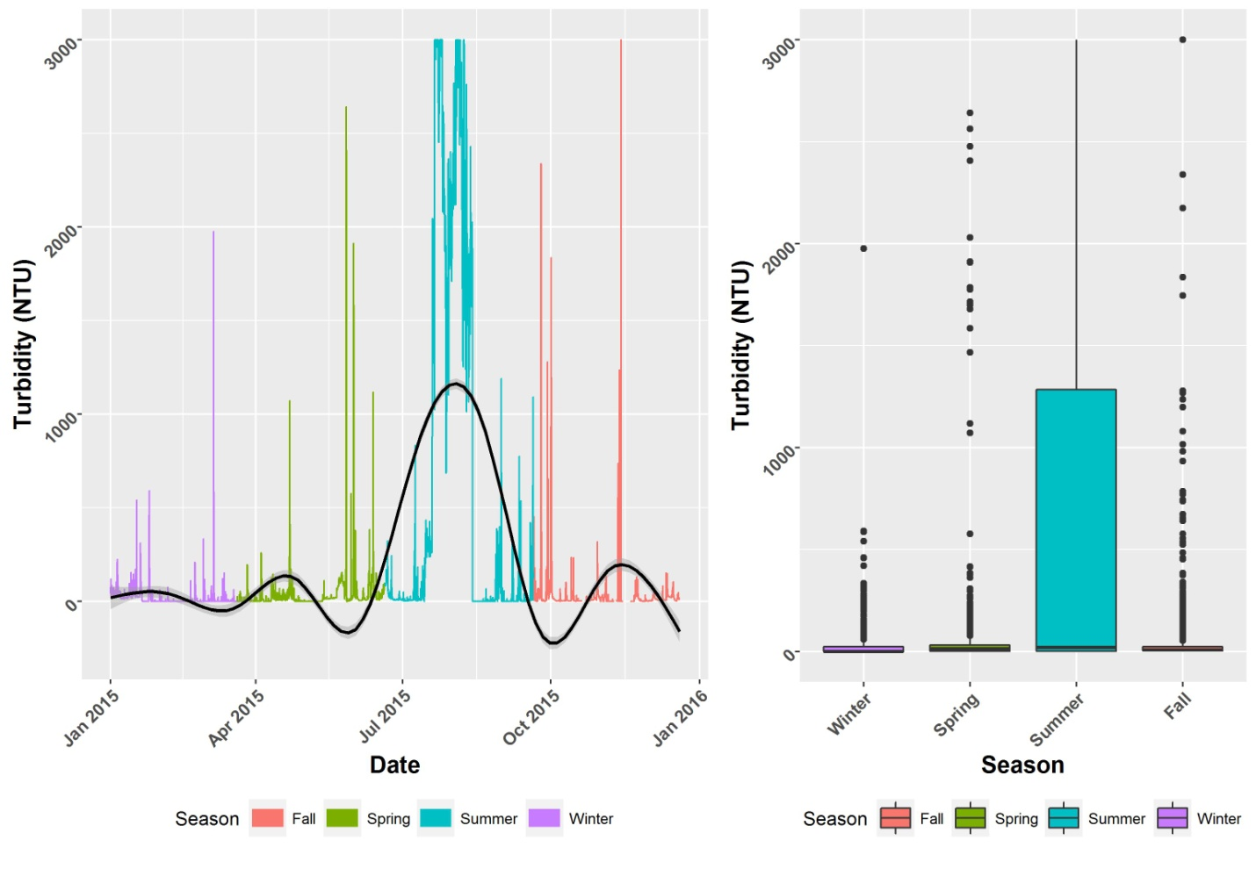
Figure 5. Within-year turbidity changes for 2015 in Little Sackville River using Environment and Climate Change Canada data (T. Smith 2016).
Turbidity is obviously generally higher in the summer months, at a time when human activity such as construction is greatest. Spikes of turbidity increase can obviously occur at any time throughout the year and are likely related to runoff events at that time.
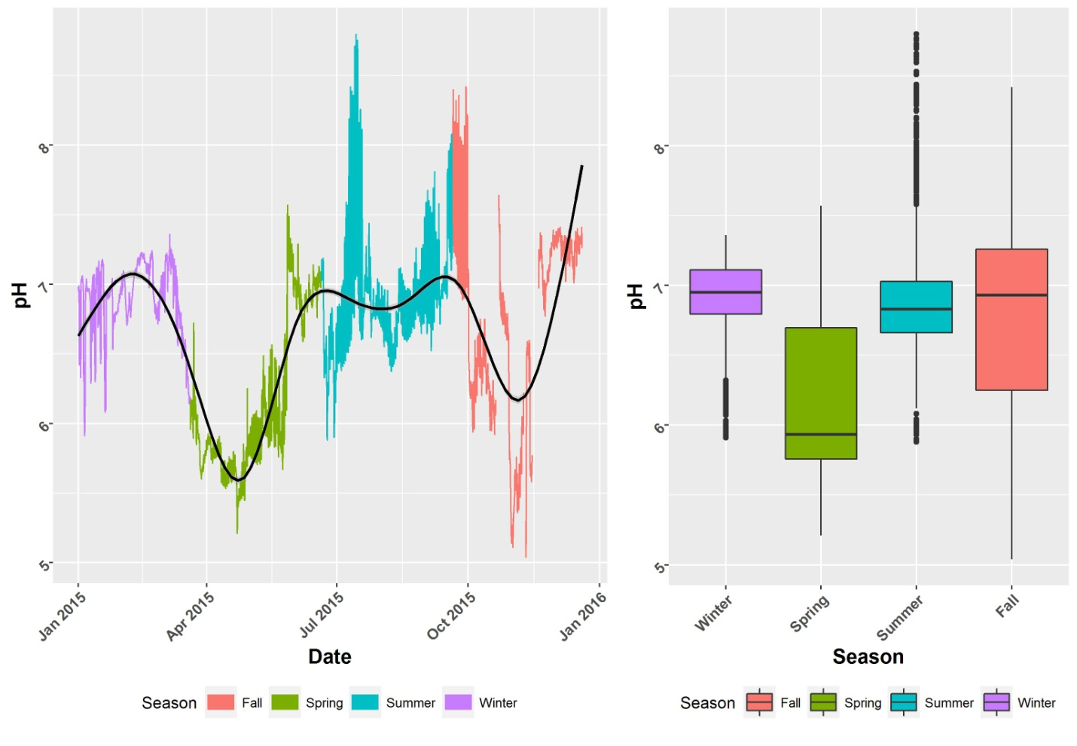
Figure 6. Within-year (2015) pH changes in Little Sackville River using Environment and Climate Change Canada data (T. Smith 2016).
The pH changes in the Little Sackville River are less pronounced than in the main stem of the Sackville River and appears to be lowest during the spring. This would seem to support the possibility that the reduced pH is due to atmospheric deposition, since it has been established that acidic deposits from the atmosphere can accumulate in winter snowpack, resulting in more substantial pH reductions in receiving streams when that snowpack melts (Atlantic Salmon Federation (2016)).
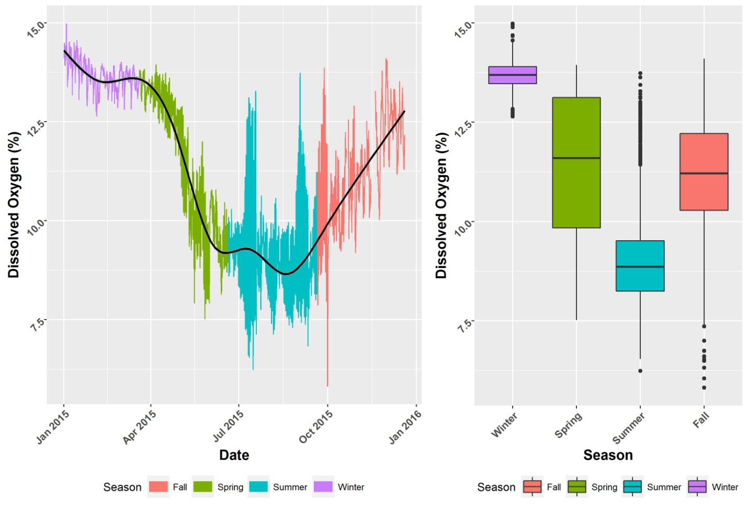
Figure 7. Within-year (2015) dissolved oxygen changes in Little Sackville River using Environment and Climate Change Canada data (T. Smith 2016).

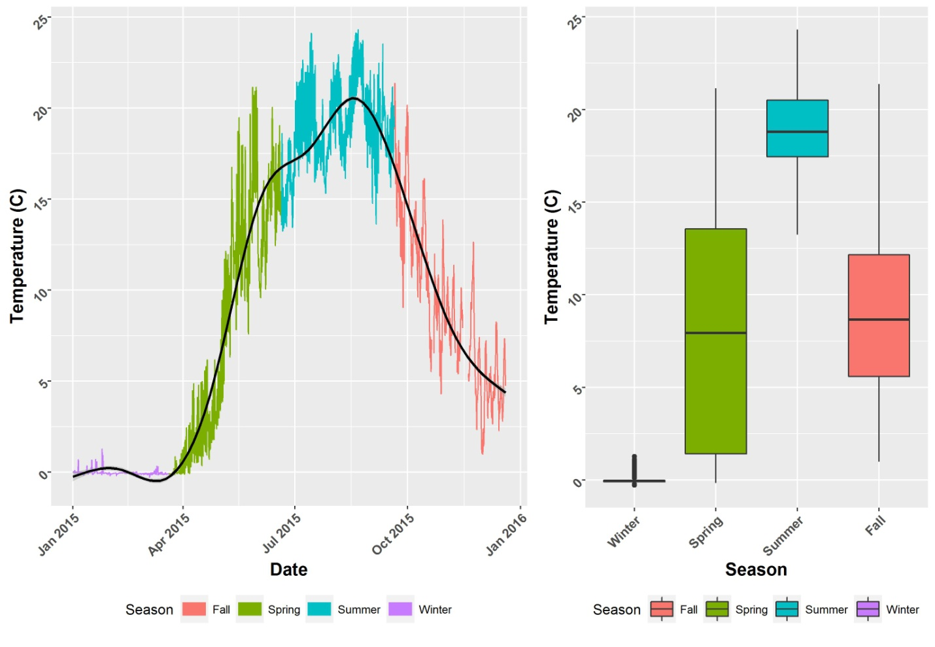
Figure 8. Within-year (2015) temperature changes in Little Sackville River using Environment and Climate Change Canada data (T. Smith 2016).

Dissolved oxygen and temperature in the Little Sackville River are inversely correlated. While the dissolved oxygen is generally very good, temperature spikes in the summer months are of a magnitude to cause stress to salmonid fish and would no doubt cause them to seek cooler water. Those spikes are probably due to runoff events from dark impermeable surfaces in the largely residential area which the Little Sackville River drains.
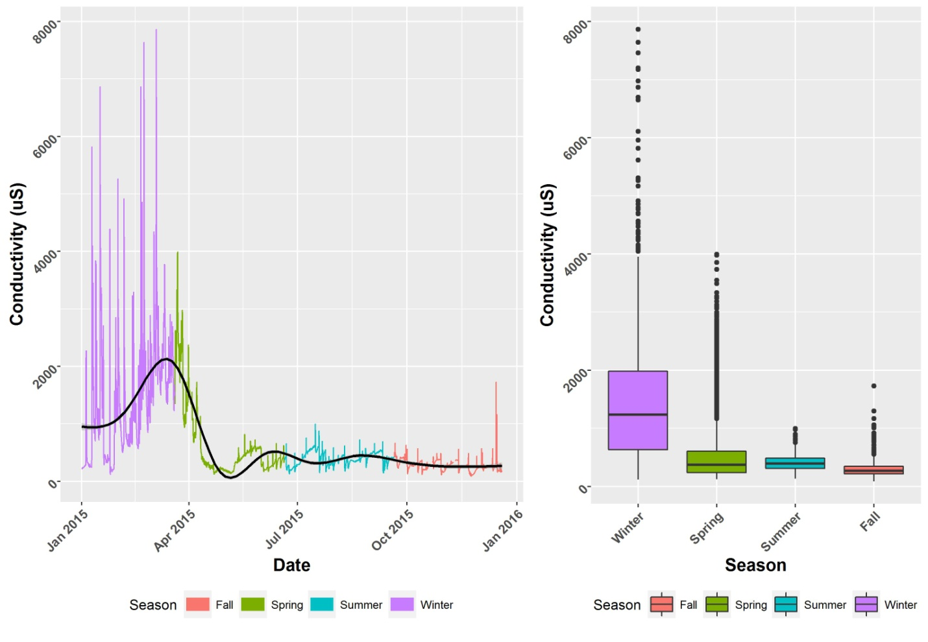
Figure 9. Within-year (2015) conductivity changes in Little Sackville River using Environment and Climate Change Canada data (note µSiemens/cm is equivalent to µmhos/cm) (T. Smith 2016).
While conductivity in the Little Sackville River was generally moderate during the summer months, it was substantially higher in the winter months. A likely reason for the higher conductivity in the winter months is the flushing of road salt into the river.
Figure 10 presents the conductivity changes with water level in the LSR as measured by Environment and Climate Change Canada (C. Garron 2016). It demonstrates that in winter months, conductivity changes are closely matched by changes in water level and can be interpreted to mean that road salt being washed into storm drains during melt periods is the cause of conductivity changes.

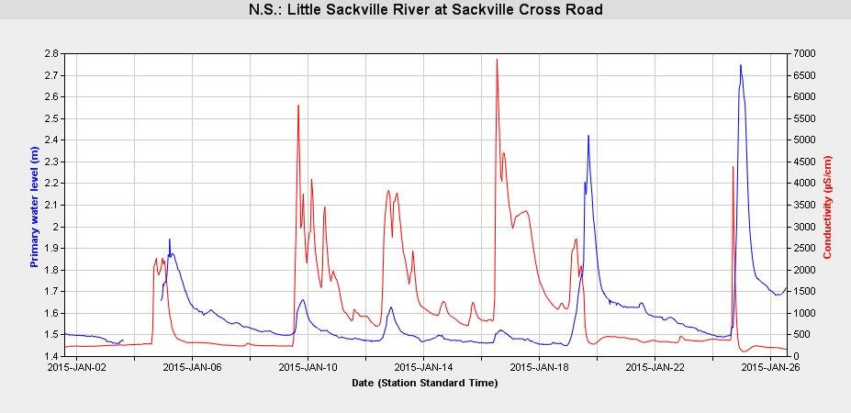
Figure 10. Conductivity and water level changes in the Little Sackville River for the month of January 2015 using Environment and Climate Change Canada monitoring data (C. Garron 2016)*
*While Environment and Climate Change Canada employs reasonable efforts, whenever feasible, to ensure the currency, accuracy and precision of the information provided, some of this material has limitations due to the sources of the data and the technology used in processing and managing the data. Furthermore, the material or any data derived using the same data is subject to interpretation. Users are responsible for verifying that the material is appropriate for the use or application for which they wish to employ it. Environment and Climate Change Canada makes no representation or warranty of any kind, either expressed or implied, as to the information presented in this application nor as to its fitness for any particular use, and Environment and Climate Change Canada does not assume nor accept any liability arising from any use of the information and applications used to display or use the information. The data are not intended for any legal purpose, nor for planning or navigation purposes. The data may change from time to time as updated information is received. If any information is noted to be incorrect, please inform the Environment and Climate Change Canada contact provided within the application. These applications might contain links to third party sites. Environment and Climate Change Canada provides these links only as a service and convenience. Environment and Climate Change Canada takes no responsibility for the content at third party sites and in no way implies an endorsement or recommendation of the products, services or information found there. A third party site may have a privacy policy different from that of Environment and Climate Change Canada. Environment and Climate Change Canada does not assume nor accept any liability arising from any use of third party sourced content. Users should use the information on this website with caution and do so at their own risk. The Government of Canada accepts no liability for the accuracy, availability, suitability, reliability, usability, completeness or timeliness of the data or graphical depictions rendered from the data. The near real-time information presented on this website is received via satellite or land-line transmissions from hydrometric gauging stations operated by Environment Canada and its Partners. These data are normally posted (in graphical form) within six hours of observation. The data are preliminary and have been transmitted automatically with limited verification and review for quality assurance. Subsequent quality assurance and verification procedures may result in differences between what is currently displayed and what will become the official record. It is the responsibility of all persons who use this site to independently confirm the accuracy of the data, information, or results obtained through its use. The Government of Canada does not warrant the quality, accuracy, or completeness of any information, data or product from these web pages. It is provided 'AS IS' without warranty or condition of any nature. The Government of Canada disclaims all other warranties, expressed or implied, including but not limited to implied warranties of merchantability and fitness for a particular purpose, with respect to the information, data, product or accompanying materials retrieved from this web site. In no event will the Government of Canada or its employees, servants or agents have any obligation to the user for any reason including claims arising from contract or tort, or for loss of revenue or profit, or for indirect, special, incidental or consequential damages arising from the use of this information. Information presented on this web site is considered public information and may be distributed or copied. No agency or individual can bundle the raw information and resell the raw information. However, agencies and individuals may add value to the data and charge for the value added options. An appropriate byline acknowledging Environment Canada is required. For further details, please refer to copyright terms and conditions
Research Projects on Chemical Contaminants.
The discharge from the HRM landfill was characterized while it was still in operation (Ernst et al. 1994, Rutherford et al. 2000) and it was shown that the discharges from the treated effluent had elevated chemical constituents such as ammonia, organic carbon, high BOD, sulphate, magnesium, aluminum and potassium, which may have had a toxic effect on benthic invertebrates within the river. They also demonstrated that the relatively high pH and water hardness, may have had an ameliorating effect on the lower pH of the river.
Pesticides are a known contaminant in urban watersheds and some measurements for common lawn and garden pesticides have been made in the Little Sackville River (Glozier et al. 2012). While concentrations of 2,4-D, mecoprop, dicamba and glyphosate were measured in the river, particularly after rainfall events, none of the concentrations were higher than CCME guidelines (CCME 2014) for the protection of aquatic life and were generally lower than urban locations in other parts of Canada.
Environment Canada has monitored water in the Sackville River for a number of organic contaminants in support of national chemical assessment activities at various times, including: perfluorooctane sulfonate from 2007-2010 (Environment Canada 2013), triclosan from 2011 to present and BPA from 2008 to present (Garron 2016), however those chemicals appear to be below concern thresholds.
Summary.
The water quality parameters reported here for the Sackville River and its tributaries are generally good and able to support resident fish species, however water quality varies with time of year, location in the watershed, as well as meteorological conditions before and during the time of sampling.
The trend in water quality changes observable with distances downstream and throughout the year can be seen in Figure 11. Water temperature is obviously greater during spring and summer and lower in winter. There appears to be a general gradient of increasing temperature with distance downstream and residence in the lakes and stillwaters is the likely cause.
Conductivity was generally low to moderate in the main stem of the Sackville River, and while this could indicate a low pollution input, it also may indicate a low biological productivity potential. The Little Sackville River on the other hand, has generally higher conductivity indicating possible higher biological productivity potential, but also may indicate a greater input of pollutants from the higher density residential drainage.
The pH of the main stem of the Sackville River is generally higher in the spring/ summer and lower in the fall/winter. There also appears to be a gradient of increasing pH with distance downstream. The exception to this is the Tomahawk Run location 9Site 7), which is a known area of low pH and is likely due to geological conditions.

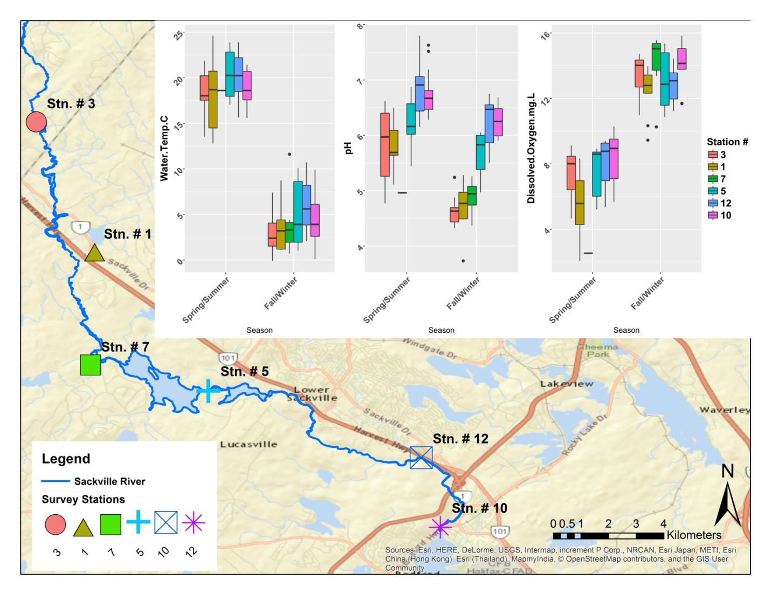
Figure 11. Within-year summary water temperature, pH and dissolved oxygen for selected sampling stations on the main stem of the Sackville River indicating seasonal and downstream changes for 2015.
There are locations in the river where water quality is not suitable for salmonid reproduction and survival for some periods of time. The upper reaches of the main stem and Tomahawk Run have unsuitable pH in the fall and winter periods. Substantial stretches of the main stem are unacceptably warm in the summer, which may cause trout and salmon to seek refuge in cooler lake water or near groundwater discharges
While historical data were not extensively searched or analyzed, in comparing the 2015/2016 SRA data with that obtained since the 1950s, it initially appears that water quality has not changed substantially for a number of decades, notably for pH, which was also observed by Watt et al. 2000. Figure 12 presents a calculation of the annual means of monthly field pH measurements reported by Watt et al. 2000 at a Sackville River station between the years 1981 to 1995. Those means varied somewhat over that 14 year period, but not substantially. The Sackville Rivers monitoring site which is closest to the Watt et al site is site 1 and the mean annual pH was 5.5 from samples taken at that location, considerably better than the 1981-1995 reported pH.

Figure 12. Annual means of monthly pH field measurements, 1981-1995, calculated from the data of Watt et al. 1996, for the Sackville River near Station 1 of the SRA monitoring program.
Recommendations.
The Sackville Rivers Association (SRA) monitoring activities have proved to be a useful method for assessing the overall quality of the river in supporting biological communities. The following recommendations are offered in the spirit of improving assessments in the future.
- Some sampling stations have been changed over the years, which are no doubt a function of changing priorities in identifying problem areas and may relate to changing access issues. It is essential to have permanent year to year stations in order to measure long term trends in water quality, however having a portion of the sampling effort directed at more flexible locations to measure short term issues is probably appropriate.
- The extent of the water sampling effort should be evaluated. The current database is probably adequate to determine the overall changes in water quality as it passes through the watershed.
- The Environment and Climate Change Canada monitoring effort has produced a comprehensive dataset whose thorough analysis will provide a good indicator of the general conditions of the Sackville and Little Sackville Rivers. That is publicly available data and that organization is willing to help in accessing and analyzing the data. That connection should be made.
- Annual sampling is highly desirable as changes in water quality values are substantive throughout the year.
- While the water quality measures that have been conducted to date are informative, additional water quality parameters, such as nutrients, turbidity and contaminants, particularly metals, should be added, if feasible, as they are good indicators of urban pollution issues.
- The water quality monitoring thus far has focussed on the river itself. It would probably be informative to sample some of the lakes within the watershed, since they can be ‘sinks’ for some contaminants and are often where water quality changes within a watercourse. Lake water profiles by depth might be useful for periodic assessment of lake water quality.
- Sampling at the time of runoff events should be considered, since the ‘first flush’ phenomena is often when the largest changes in some water quality parameters is seen.
- Some consideration should be given to a more ‘integrated’ sampling method as a measure of overall environmental health. An example is the CABIN program lead by Environment and Climate Change Canada using benthic invertebrate assemblages as a measure of watercourse health; however fish health/abundance measures might also be useful.
- This analysis did not attempt to analyze all of the SRA data, partially due to time and effort limitations, but also due to some possible issue with quality control; however that should be considered if student help is available. At minimum, annual data reports should be produced, since without such analyses, the monitoring effort is not worthwhile.
Acknowledgements.
Environment and Climate Change staff, Christine Garron, Todd Smith and Denis Parent are thanked for their provision of data and advice on interpretation. The assistance of Bevan Ernst in data analysis and plotting is gratefully acknowledged. Shane Oneil and Walter Regan provided useful comments on the report. Rosslyn Ernst was of great assistance in report formatting.

References.
Alabaster, J.S. and R. Lloyd. 1980. Water quality criteria for freshwater fish. European Inland Fisheries Advisory Commission Report (FAO). Buttersworth, London-Boston. 297pp.
Atlantic Salmon Federation. 2016. Acid rain kills Nova Scotia Rivers. http://www.oldsalmon.ca/docs/issues/acidrain.pdf Accessed June 2016
Beanlands, D.I. 1980. Surveys of ten lakes in Guysborough, Halifax, Hants and Lunenburg Counties, Nova Scotia, 1978. Canadian Data Report of Fisheries and Aquatic Sciences No. 192. Fisheries and Oceans Canada. ISSN 0706-6465.
Boyd, C.E. 1990. Water quality in ponds for aquaculture. Alabama Agricultural Experiment station, Auburn University, Auburn, Alabama. Birmingham Publishing Co., Birmingham, Alabama. 482pp
Brunner, J. W. 2010. Sackville River watershed wetland inventory. Sackville Rivers Association, Sackville, Nova Scotia. Upubl. Report. Clancey, J. 2012. A study of the Tomahawk Lake and Tomahawk Run watershed to determine sources of acidity effecting the watershed and suitability of liming the watershed to restore Atlantic salmon habitat. Unpublished report SRA files 18pp.
Environment Canada 2013. Perfluoroocatane sulfonate in the Canadian environment. Environmental Monitoring and Surveillance in Support of the Chemicals Management Plan. ISBN 978-1-100-22426-8.
Ernst, W.R., P. Hennigar, K. Doe, S. Wade. and G. Julien. 1994. Characterization of the chemical constituents and toxicity to aquatic organisms of a municipal landfill leachate. Water Poll.Res. J. Can. 29:89-101
Farmer, G.J. 2000. Effects of low environmental pH on Atlantic salmon (Salmo salar L.) in Nova Scotia. Canadian stock Assessment Secretariat, CSAS. Research document 2000/050 ISSN 1480-4883, Ottawa.
Canadian Council of Ministers of Environment (CCME). 2014. Canadian Environmental Quality Guidelines. http://www.ccme.ca/en/resources/canadian_environmental_quality_guidelines/
Garron, C. 2016. Personal communication. Environment and Climate Change Canada, Dartmouth, Nova Scotia. B2Y 2N6
Glozier, N., J. Struger, A.J. Cessna, M. Gledhill, M. Rondeau, W.R. Ernst, M. A. Sekela, S.J. Cagampan, E. Sverko, C. Murphy, J.L. Murray, and D.B. Donald. 2012. Occurrence of glyphosate and acidic herbicides in select urban rivers and streams in Canada. Environ. Sci. Pollut. Res. 19:821-834.
Gorham, E. 1957. The chemical composition of lake waters in Halifax County, Nova Scotia. Limnol. Ocean. 2(1): 12-21
Horne, R.J., R.J. Ryan, M.C. Corey and D.L. Fox. 2009 Bedrock geology map of Pockwock lake area, part of NTS sheet 11D/13, Halifax and Hants counties, Nova Scotia department of Natural Resources Mineral Resources Branch, Open file Map ME 2009-3 scale 1:2500
MacDougall, J.I., D.B Cann and J.D. Hilchey. 1963. Soil survey of Halifax County. Report No. 13, Nova Scotia Soil Survey, Agriculture Canada, Truro, Nova Scotia.
McKee, J.E. and H.W. Wolf. 1963. Water quality criteria (2nd ed.) State Water Control Board, Sacramento, CA. Pub. No. 3-A
National Academy of Sciences (NAS). 1972. Water quality criteria 1972. A report of the Committee on water Quality Criteria. Prepared by the National academy of Sciences and National Academy of Engineering.
National Oceanic and Atmospheric Administration (NOAA) 2016. Essential fish habitat description, Atlantic salmon (Salmo salar) . http://www.greateratlantic.fisheries.noaa.gov/hcd/salmon.pdf
Nova Scotia Salmon Association. 2014. “Walking the river” A citizen’s guide to interpreting water quality data. Nova Scotia Salmon Association NSLC Adopt a Stream Program.
Nova Scotia Department of Natural Resources. 2016. Digital surficial geological data of the Halifax metropolitan and surrounding areas of Nova Scotia. DPME 447, version 1, 2011. D.J. Utting, NS Dept. Nat Res. Novacotia.ca/natr/meb/download/dp447.asp. Accessed April 20, 2016
Parent, D. 2016. Personal communication. Environment and Climate Change Canada, Dartmouth, Nova Scotia. B2Y 2N6
Rutherford, L.A., S.L. Matthews, K.G. Doe and G.R. Julien. 2000. Aquatic toxicity and environmental impact of leachate discharges from a municipal landfill. Water Qual. Res. J. Canada. 35(1):39-57.
Scott, W.B and E.J. Crossman. 1973. Freshwater Fishes of Canada. Bull. 184. Fish. Res. Bd. Can. Ottawa.
Smith, T. 2016. Personal communication. Environment and Climate Change Canada, Dartmouth, Nova Scotia. B2Y 2N6.
Stantec. 2012. An analysis of the HRM Lakes Water Quality Monitoring Program data. (2006-2011). Stantec Consulting Ltd., Dartmouth NS. File 121510918.
Sterling, S., K. Garroway, Y. Guan, S. Ambrose, P. Horne, and G. Kennedy. 2014. A new watershed assessment framework to improve water resource planning in Nova Scotia. J. Hydol. In press.
U.S. Environmental Protection Agency (USEPA). 2003. Protecting water quality from urban runoff. EPA 841-F-03-003. (http://www.epa.gov/npdes/pubs/nps_urban-fact_final.pdf).
Wallace, A.M. and R.G. Biastoch. 2016. Detecting changes in the benthic invertebrate community in response to increasing chloride in streams in Toronto, Canada. Freshwater Science. 35(1):353-363.
Watt, W.D., C.D. Scott, and P. Mandell. 1996. Water chemistry data from a monitoring program designed to detect changes in the long range transport of acidic pollutants into Nova Scotia’s acidified Atlantic salmon rivers. Canadian Data Report of Fisheries and Aquatic Sciences no. 972. Fisheries and Oceans Canada. Ottawa.
Watt, W.D., C.D. Scott, P.J. Zamora and W.J. White. 2000. Acid toxicity levels in Nova Scotian rivers have not declined in synchrony with the decline in sulphate levels. Water Air and Soil Pollution 118:203-229.
Wetzel, R.G. 1975. Limnology. W.B Saunders Co., Toronto. 743pp
White, C.E., L. Trudell and R. Hamblin. 2014. An update on the acid-generating potential of rocks in Southwestern Nova Scotia , with emphasis on the metropolitan Halifax Regional Municipality. In Mineral Resources Branch, Report of Activities 2013; Nova Scotia Department of Natural Resources, report ME 2014-001, pp 67-80.
White, T. 2004. Water quality research on the Sackville Rivers watershed (2001-2003). Unpublished report, Sackville Rivers Association, Sackville, N.S. 50pp.
World Wildlife Fund (WWF). 2016. Watershed Reports. Watershedereports.wwf.ca accessed June 2016.

